**7 kyu**

**Playing with Sets : Intersection**

2496% of3493[ZozoFouchtra](https://www.codewars.com/users/ZozoFouchtra)

JavaScript

* [TRAIN AGAIN](https://www.codewars.com/kata/playing-with-sets-intersection/train/javascript)
* [NEXT KATA](https://www.codewars.com/trainer/javascript)

Details

[Solutions](https://www.codewars.com/kata/playing-with-sets-intersection/solutions/javascript)

[Discourse (1)](https://www.codewars.com/kata/playing-with-sets-intersection/discuss/javascript)

* Add to Collection
* |
* Share this kata:

[Set](https://developer.mozilla.org/en-US/docs/Web/JavaScript/Reference/Global_Objects/Set) objects are new JavaScript built-in objects defined since [ECMAScript 2015](http://www.ecma-international.org/ecma-262/6.0/" \l "sec-set-objects." \t "_blank)

A **Set** lets you store unique values of any type. It comes with some useful methods like .add, .clear, .has . . . **BUT**some "Set operations" are missing, like . . .

**Intersection**

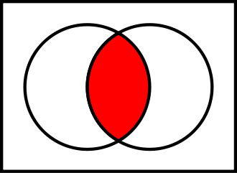

A new set can be constructed by determining which members two sets have "in common". The **intersection** of A and B, denoted by A ∩ B, is the set of all things that are members of both A and B. If A ∩ B = ∅, then A and B are said to be **disjoint**.

**Examples:**

{1, 2} ∩ {1, 2} = {1, 2}.

{1, 2} ∩ {2, 3} = {2}.

**Task**

Create function inter getting 2 sets as arguments and returning a **new Set** as result of intersection of these 2 sets.

**Examples:**

A = new Set([1,2]);

B = new Set([2,3]);

C = inter(A,B) // -> {2}

" May the Code be with you ! "

<https://www.codewars.com/kata/playing-with-sets-intersection/javascript>

**function inter(s1, s2) {**

**const s3 = new Set()**

**for (const item of s1) {**

**if (s2.has(item)) {**

**s3.add(item)**

**}**

**}**

**return s3**

**}**